+9V Battery Power Rail Generator

A design of a DC/DC converter was needed for a battery powered project consisting of PICs and other ICs.

The rails needed were +24V,+12V and +5V from a 9V supply.

The choice was made to implement the design using 1 switch mode converter and 2 regulators

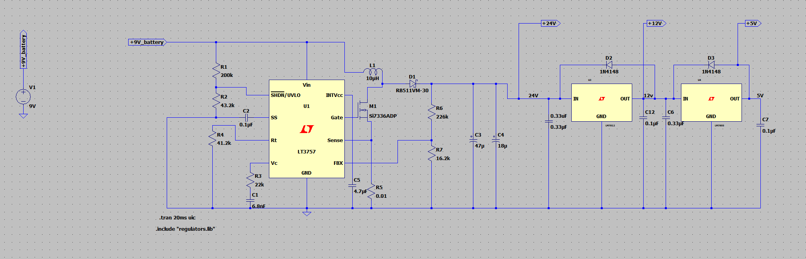The circuit was tested and simulated in LTSpice prior to creation. (see figure 1 and 2)

Figure : LTSpice schematic

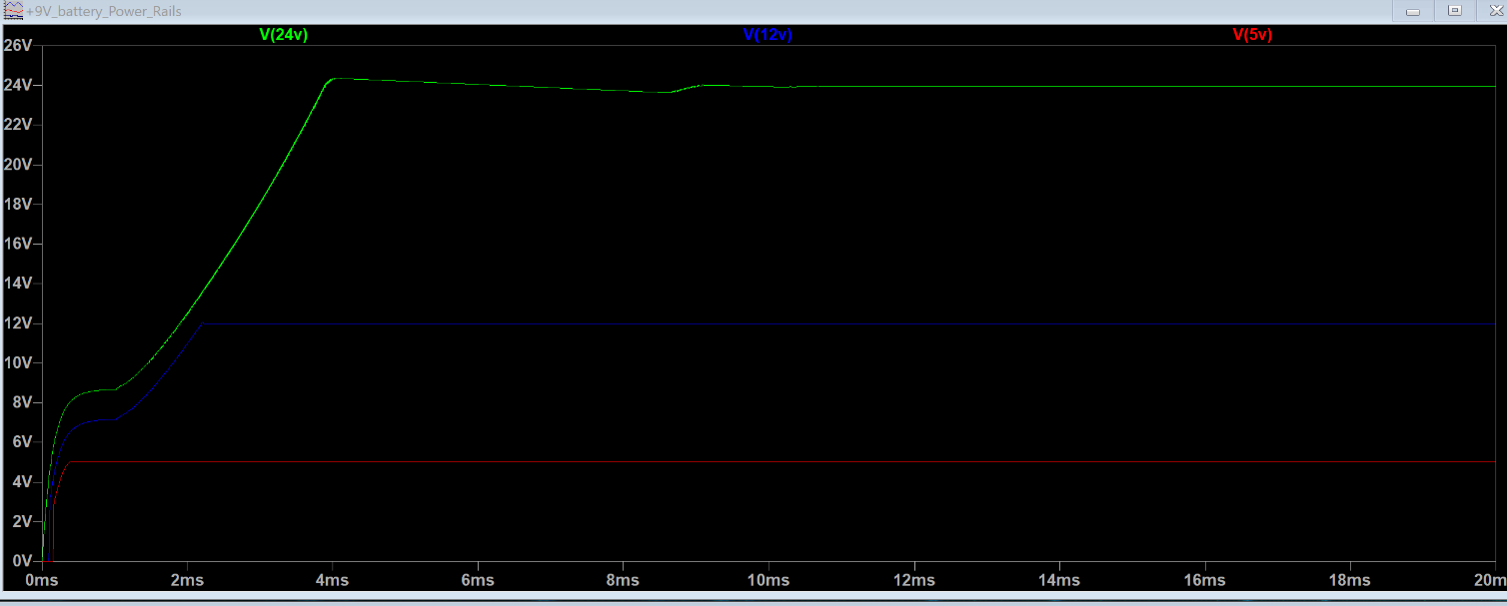Once the design was verified and timing conditions and power conditions were met, a test PCB was developed in KiCAD for implementation in the project. (Tester PCB shown here not wider design) (see figures 3,4 and 5)

Figure : LTSpice Simulation

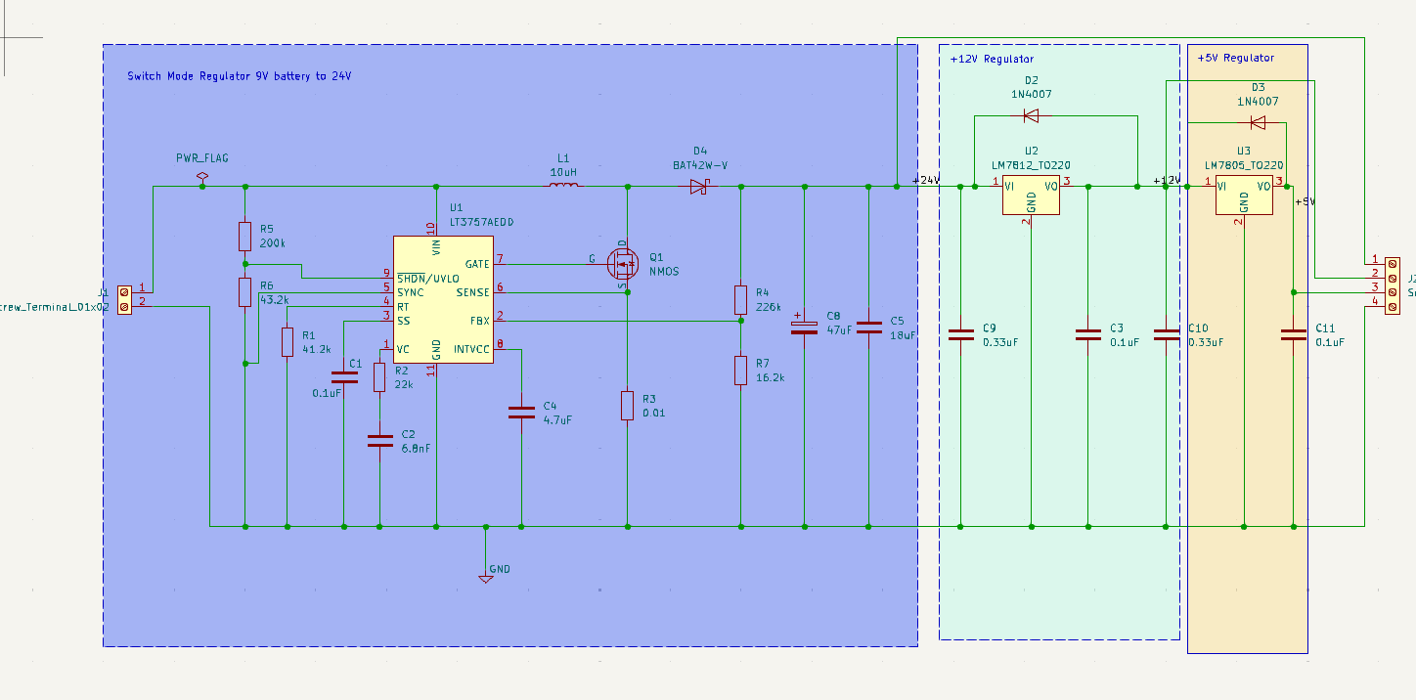

Figure :KiCAD Schematic

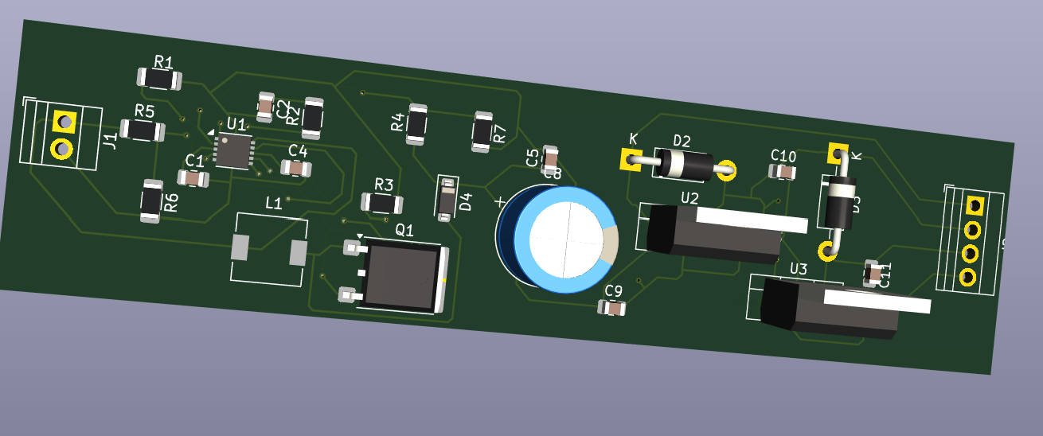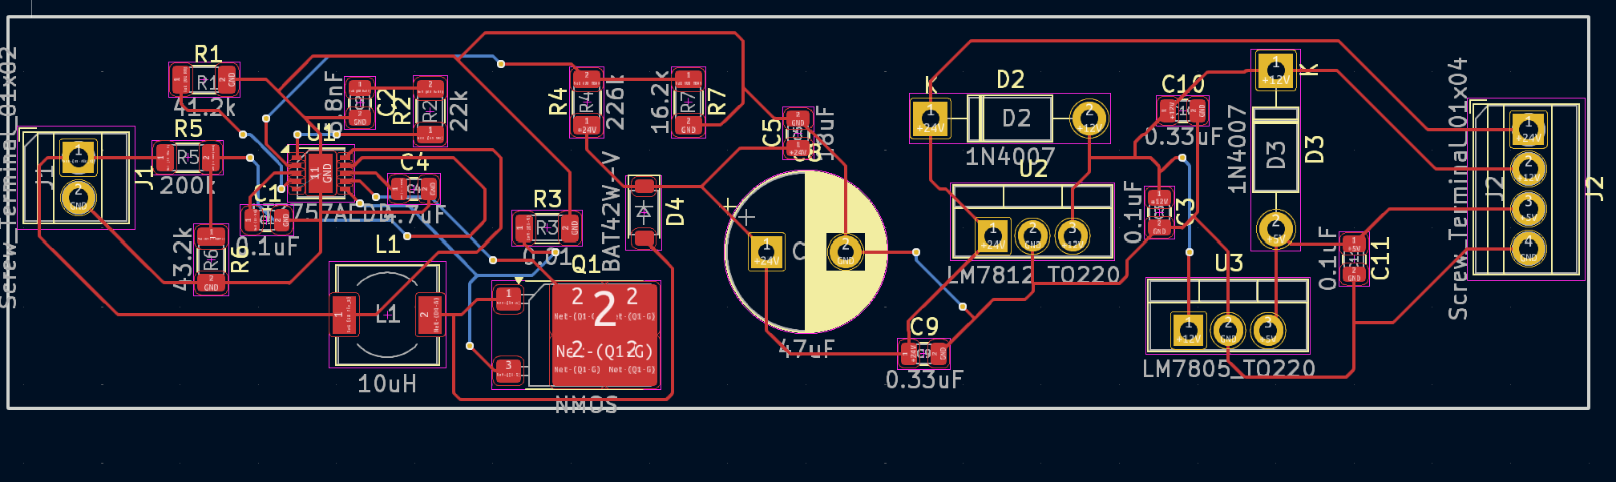

Figure 6:3D model of PCB

Figure : KiCAD PCB